- Conditional Statements

num = float(input("Enter a number: ")) if num > 0:
print("The number is positive.") elif num < 0:
print("The number is negative.")
else:
print("The number is zero.")

OUTPUT
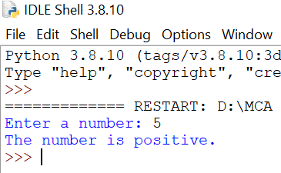

RESULT
The given program was executed successfully.

- Triangle Pattern

rows = int(input("Enter number of rows: ")) for i in range(1,rows+1):
for j in range(1,i+1): if j==4:
break if j==2:
continue if j==3:
pass print(j,end="")
print()

OUTPUT
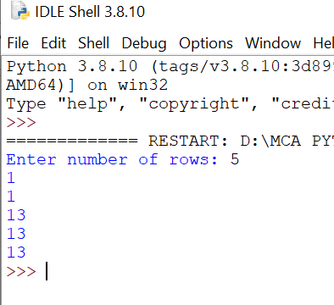

RESULT
The given program was executed successfully.

- Recursive Functions and Lambda with Reduce()

from functools import reduce def fact(n):
if n==0 or n==1: return 1
else:
return n* fact(n-1) num=int(input("Enter a Number:")) print("Factorial (recursion) : ",fact(num))
factorial = reduce(lambda x,y:x*y,range(1,num+1)) print("Factorial (Lambda) : ",factorial)

OUTPUT
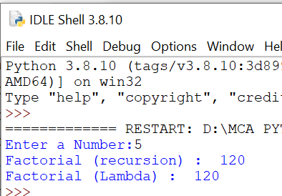

RESULT
The given program was executed successfully.

- Mini Banking System

Main.py
import bnk while True:
print("\n--- Mini Banking System ---") print("1. Deposit")
print("2. Withdraw") print("3. Balance Inquiry") print("4. Exit")
choice = int(input("Enter your choice: ")) try:
if choice == 1:
amount = float(input("Enter deposit amount: ")) print("Balance after deposit:", bnk.deposit(amount))
elif choice == 2:
amount = float(input("Enter withdrawal amount: ")) print("Balance after withdrawal:", bnk.withdraw(amount))
elif choice == 3:
print("Current Balance:", bnk.check_balance()) elif choice == 4:
print("Thank you for using the banking system.") break
else:
print("Invalid choice!") except Exception as e:
print("Error:", e)

bnk.py
balance = 0
def deposit(amount):
global balance balance += amount return balance
def withdraw(amount):

global balance
if amount > balance:
raise Exception("Insufficient balance!") balance -= amount
return balance def check_balance():
return balance

OUTPUT
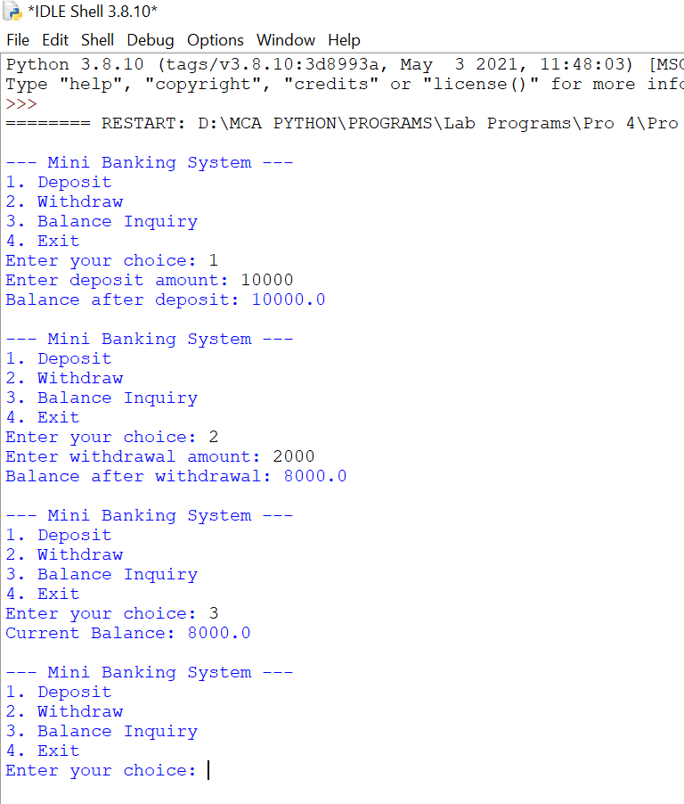

RESULT
The given program was executed successfully.

- Employees Performance Using Conditional Logic

class employee:
def init (self,emp_id,name,salary,performance): self.emp_id=emp_id
self.name=name self.salary=salary self.performance=performance
def bonus_calculate(self):
if self.performance=="Excellent": bonus=self.salary*0.20
elif self.performance=="Good": bonus=self.salary*0.10
elif self.performance=="Average": bonus=self.salary*0.05
else:
bonus=0 return bonus
def display(self):
print("Employee Id:",self.emp_id) print("Employee Name:",self.name) print("Employee Salary:",self.salary) print("Employee Performance:",self.performance) print("Employee Bonus:",self.bonus_calculate()) emp_id=int(input("Enter Employee ID:")) name=input("Enter Employee Name:") salary=int(input("Enter Employee Salary:"))
performance=input("Enter Employee Performance(Excellent/Good/Average):") emp=employee(emp_id,name,salary,performance)
emp.display()

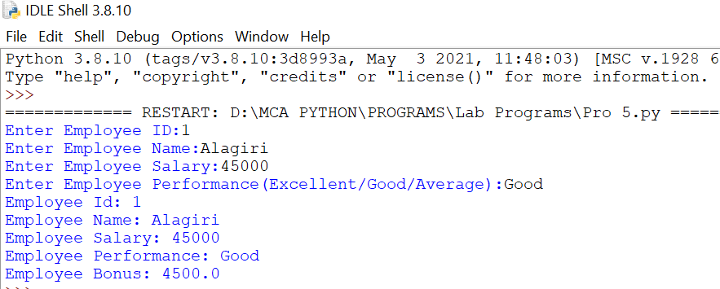

RESULT
The given program was executed successfully.

- Book and Library classes

class Book:
def init (self, book_id, title, author): self.book_id = book_id
self.title = title self.author = author self.is_available = True
def display_book(self):
status = "Available" if self.is_available else "Borrowed"
print(f"ID: {self.book_id}, Title: {self.title}, Author: {self.author}, Status: {status}") class Library:
def init (self): self.books = []
def add_book(self, book): self.books.append(book) print("Book added successfully!")
def search_book(self, title): found = False
for book in self.books:
if book.title.lower() == title.lower(): book.display_book()
found = True if not found:
print("Book not found.") def borrow_book(self, book_id):
for book in self.books:
if book.book_id == book_id: if book.is_available:
book.is_available = False print("Book borrowed successfully!")
else:
print("Book is already borrowed.") return

print("Book ID not found.") def return_book(self, book_id):
for book in self.books:
if book.book_id == book_id: if not book.is_available:
book.is_available = True print("Book returned successfully!")
else:
print("Book was not borrowed.") return
print("Book ID not found.") def display_all_books(self):
if not self.books:
print("No books in library.") for book in self.books:
book.display_book() library = Library()
while True:
print("\n--- Library Menu ---") print("1. Add Book")
print("2. Search Book") print("3. Borrow Book") print("4. Return Book") print("5. Display All Books") print("6. Exit")
choice = input("Enter your choice: ") if choice == "1":
book_id = int(input("Enter Book ID: ")) title = input("Enter Book Title: ") author = input("Enter Author Name: ")
library.add_book(Book(book_id, title, author)) elif choice == "2":
title = input("Enter book title to search: ") library.search_book(title)

elif choice == "3":
book_id = int(input("Enter Book ID to borrow: ")) library.borrow_book(book_id)
elif choice == "4":
book_id = int(input("Enter Book ID to return: ")) library.return_book(book_id)
elif choice == "5": library.display_all_books()
elif choice == "6":
print("Exiting Library System. Goodbye!") break
else:
print("Invalid choice. Please try again.")

OUTPUT
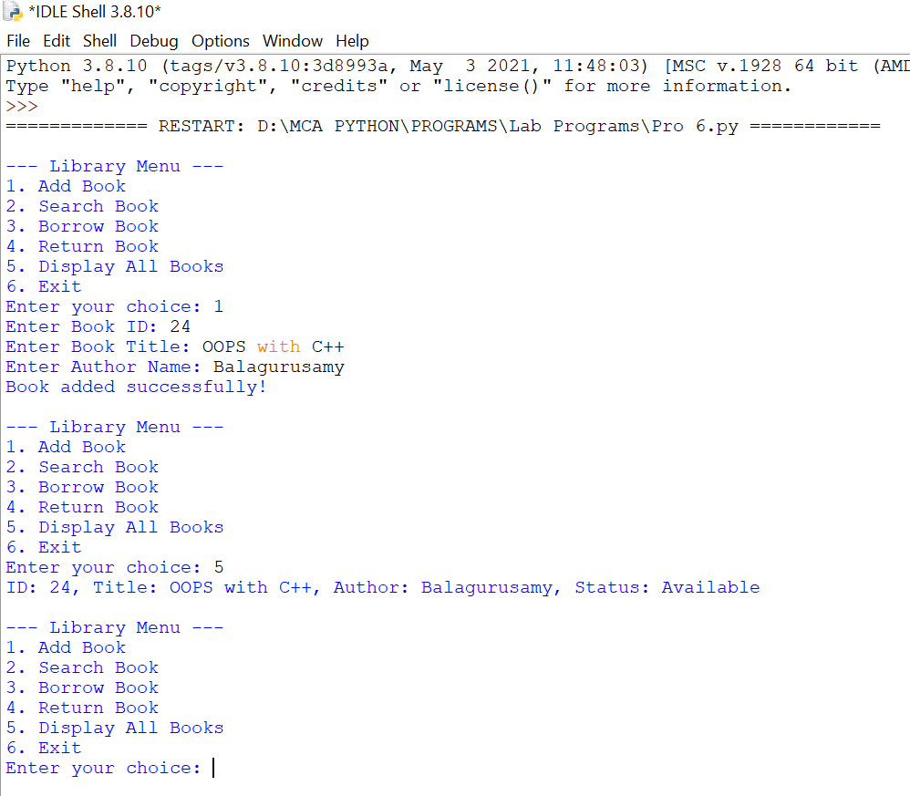
RESULT
The given program was executed successfully.

SOURCE CODE
- Student Details Using File

file_name = "students.txt" def add_student():
roll = input("Enter Roll Number: ") name = input("Enter Name: ") marks = input("Enter Marks: ") with open(file_name, "a") as f:
f.write(roll + "," + name + "," + marks + "\n") print("Student added successfully!\n")
def search_student():
roll_search = input("Enter Roll Number to search: ") found = False
with open(file_name, "r") as f: for line in f:
data = line.strip().split(",") if data[0] == roll_search:
print("Student Found!") print("Roll:", data[0])
print("Name:", data[1])
print("Marks:", data[2]) found = True
break if not found:
print("Student not found.\n") def update_marks():
roll_update = input("Enter Roll Number to update: ") new_marks = input("Enter New Marks: ") updated_data = []
found = False
with open(file_name, "r") as f: for line in f:
data = line.strip().split(",") if data[0] == roll_update:

data[2] = new_marks found = True
print("Marks updated successfully!") updated_data.append(",".join(data))
with open(file_name, "w") as f: for record in updated_data: f.write(record + "\n")
if not found:
print("Student not found.\n") while True:
print("\n1. Add Student") print("2. Search Student") print("3. Update Marks") print("4. Exit")
choice = input("Enter your choice: ") if choice == "1":
add_student() elif choice == "2":
search_student() elif choice == "3":
update_marks() elif choice == "4":
print("Program exited.") break
else:
print("Invalid choice!")

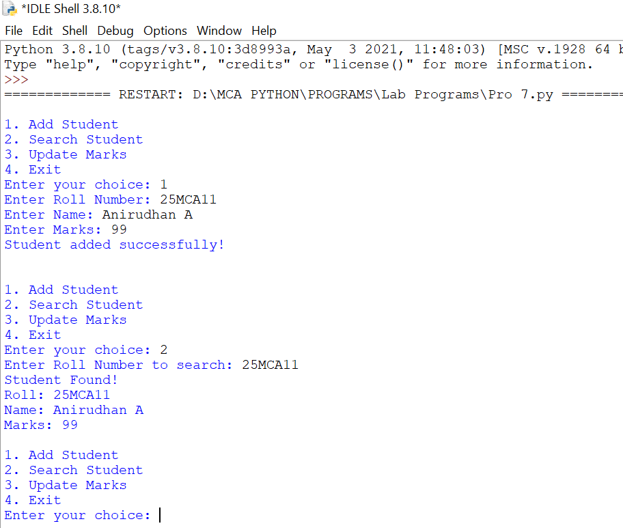

RESULT
The given program was executed successfully.

- Pandas DataFrame

import pandas as pd data = {
"Name": ["Alice", "Bob", "Charlie", "David", "Eva", "Frank", "Grace"],
"Gender": ["Female", "Male", "Male", "Male", "Female", "Male", "Female"], "Maths": [85, 78, 92, 70, 88, 76, 95],
"Science": [90, 74, 89, 65, 91, 72, 98],
"English": [88, 80, 85, 60, 87, 75, 93]
}
df = pd.DataFrame(data) print("Student DataFrame:\n") print(df)
print("\nMean Marks:")
print(df[["Maths", "Science", "English"]].mean()) print("\nMaximum Marks:")
print(df[["Maths", "Science", "English"]].max()) print("\nMinimum Marks:")
print(df[["Maths", "Science", "English"]].min()) print("\nStatistical Summary using describe():") print(df[["Maths", "Science", "English"]].describe()) print("\nGender Count:") print(df["Gender"].value_counts())

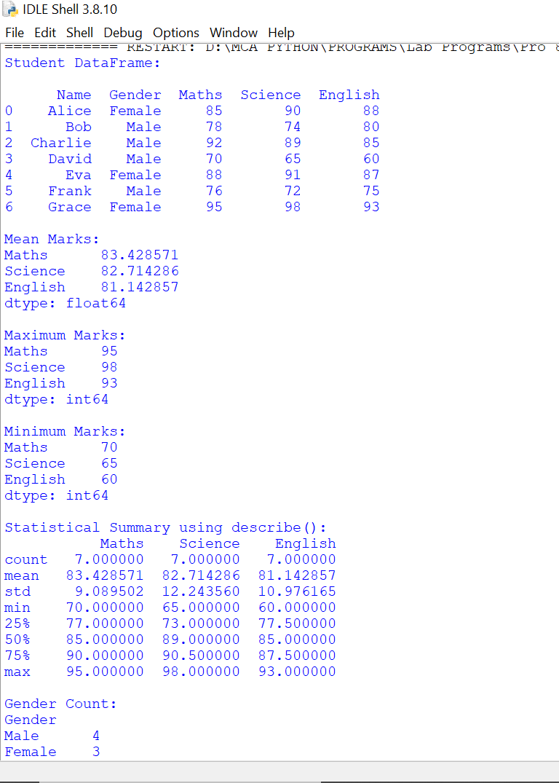

RESULT
The given program was executed successfully.

- Data visualization

import pandas as pd
import matplotlib.pyplot as plt data = pd.read_csv('expense.csv') print(data.head()) plt.figure(figsize=(10, 5))
plt.plot(data['Month'], data['Expense'], marker='o', linestyle='-', color='b', label='Monthly Expense')
plt.xlabel('Month') plt.ylabel('Expense ($)')
plt.title('Monthly Expenses - Line Chart') plt.xticks(rotation=45)
plt.legend() plt.grid(True) plt.tight_layout() plt.show() plt.figure(figsize=(10, 5))
plt.bar(data['Month'], data['Expense'], color='orange', label='Monthly Expense') plt.xlabel('Month')
plt.ylabel('Expense ($)') plt.title('Monthly Expenses - Bar Chart') plt.xticks(rotation=45)
plt.legend() plt.tight_layout() plt.show()

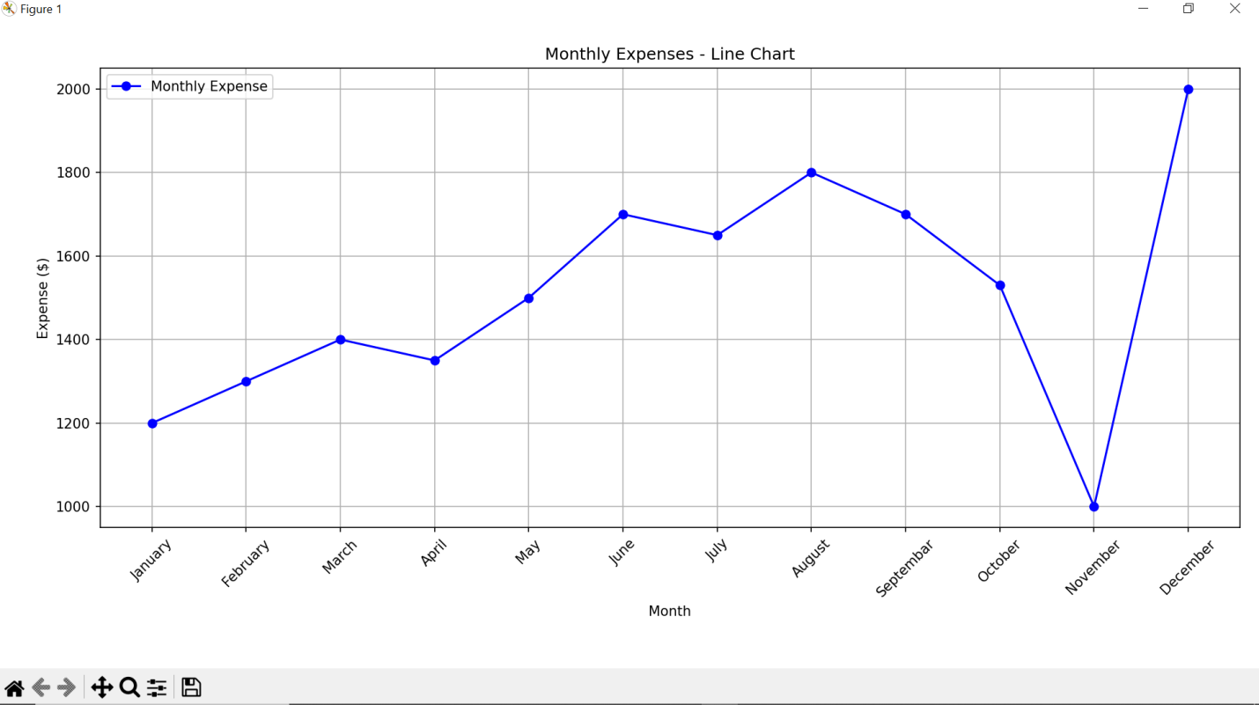
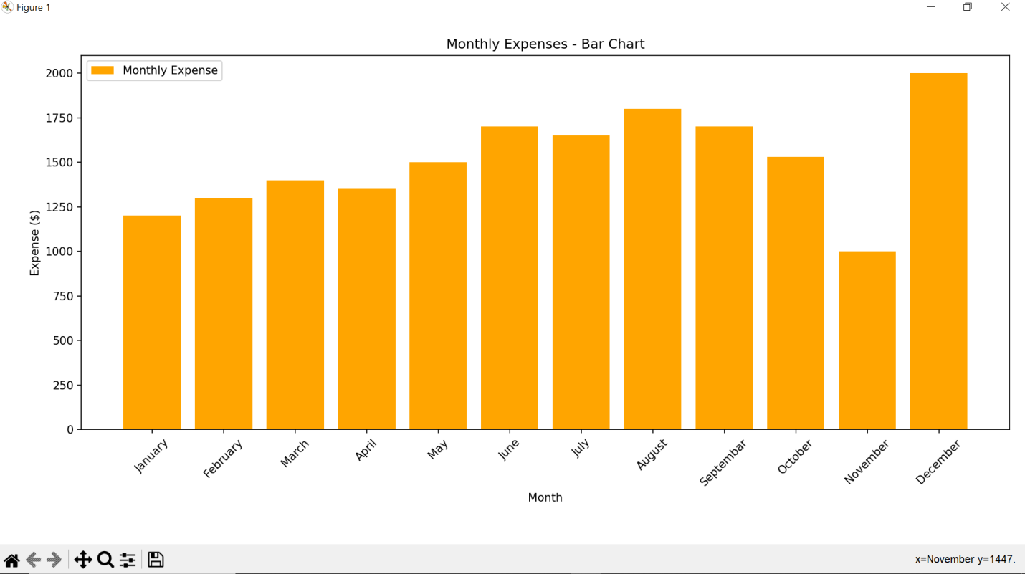

RESULT
The given program was executed successfully.

- File Manipulation

input_file = "hello.txt" output_file = "long_words.txt" line_count = 0
word_count = 0 long_words = []
with open(input_file, "r") as f: for line in f:
line_count += 1
words = line.strip().split() word_count += len(words) for word in words:
if len(word) > 5: long_words.append(word)
with open(output_file, "w") as f: for word in long_words:
f.write(word + "\n") print("Total lines:", line_count) print("Total words:", word_count)
print("Long words saved to", output_file)

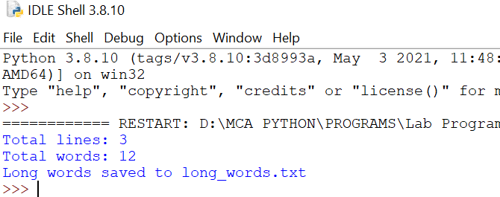

RESULT
The given program was executed successfully.

- Graphical Calculator Using Tkinter

import tkinter as tk
from tkinter import messagebox root = tk.Tk()
root.title("Simple Calculator") root.geometry("300x400") expression = ""
entry_text = tk.StringVar() def press(num):
global expression expression += str(num) entry_text.set(expression)
def equal():
global expression try:
result = str(eval(expression)) entry_text.set(result) expression = result
except ZeroDivisionError:
messagebox.showerror("Error", "Cannot divide by zero") expression = ""
entry_text.set("") except:
messagebox.showerror("Error", "Invalid input") expression = ""
entry_text.set("") def clear():
global expression expression = "" entry_text.set("")
entry = tk.Entry(root, textvariable=entry_text, font=("Arial", 18), justify="right") entry.pack(fill="both", padx=10, pady=10)

buttons = [ ['7','8','9','/'],
['4','5','6','*'],
['1','2','3','-'],
['0','C','=','+']
]
for row in buttons:
frame = tk.Frame(root) frame.pack(expand=True, fill="both") for btn in row:
if btn == "=": action = equal
elif btn == "C": action = clear
else:
action = lambda x=btn: press(x) tk.Button(
frame, text=btn,
font=("Arial", 14), command=action
).pack(side="left", expand=True, fill="both") root.mainloop()

OUTPUT
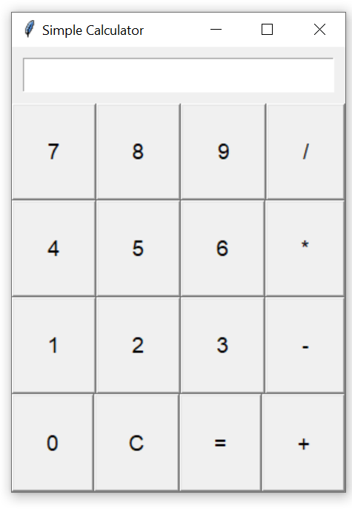

RESULT
The given program was executed successfully.

SOURCE CODE
- Django Web Application
from django.shortcuts import render def login_view(request):
message = ""
if request.method == "POST":
username = request.POST.get("username") password = request.POST.get("password")
if username == "admin" and password == "1234": message = "Login Successful"
else:
message = "Invalid Username or Password"
return render(request, "login.html", {"message": message}) #myapp/urls.py
from django.urls import path from . import views
urlpatterns = [
path("", views.login_view, name="login"),
]
#django_web/urls.py
from django.contrib import admin from django.urls import path, include urlpatterns = [
path('admin/', admin.site.urls), path('', include('myapp.urls')),
]
#templates/login.html
<!DOCTYPE html>
<html>
<head>
<title>Login Page</title>
</head>
<body>
<h2>Login Form</h2>
<form method="post">
{% csrf_token %} Username:
<input type="text" name="username"><br><br>
Password:
<input type="password" name="password"><br><br>
<input type="submit" value="Login">
</form>
<p>{{ message }}</p>
</body>
</html>

OUTPUT

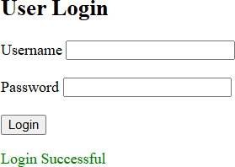

RESULT
The given program was executed successfully.

